Tohu Terminology
Term | Meaning
Questionnaire | High level entity representing all the items to capture user information
Group | A list of related questions
Section | A sub-grouping of related questions
Note | Textual help for associated to a question
Answer | The options selected by the user to a question
Item Id | Unique name given to a Group, Section, Note or Answer

Tohu Spreadsheet

Tohu Questionanire definitions
AppSet | The internal name of the application
Base | The drools package name for all the rules generated
Name | The displayable name of the application
Completion | The resource name to refer to upon completion of the Questionnaire
ActivePage | The itemId of the first page to display on the questionnaire
Action Validation | Boolean to determine if page validation is enabled or not.
Include File | ???
MarkUp Allowed | Determines whether mark up is allowed as an attribute of any Tohu Entities

Note the following from fig 1 below
- The questionnaire displayed to the user is called “Solnet Loyalty Card Signup”.
- A PDF file called “extract.pdf” representing a summary of the questionnaire, will be generated upon conclusion of the questionnaire.
- The first Tohu “page” to be displayed is the one called ContactDetailsPage
AppSet | Base | Name | Completion | ActivePage | Include File
LoyaltyCard | org.tohu.examples.loyalty | Solnet Loyalty Card Signup | extract.pdf | ContactDetailsPage

Fig 1

The Tohu generated container of the webpage looks as fig 2 below.

Fig 2 Note the Title heading.

Tohu Rule header definitions
Item ID | Unique name of Page
Item ID | Unique name of a Group/Question entity
Item ID | Unique name of a Group/Section/Question entity
Type | Type of Entity. Domain set of values are (Page, Group, MultipleChoiceQuestion, Question, Note, Branch, Impact, FunctionalImpact, AlternateImpact, Validation and Reuse)
Depends on Item Id | What other Tohu entity (using its ItemId) the current Tohu entity (row) depends on
Attribute | The attribute of the other Tohu entity. This is usually one of two fields (answer, answered)
Operation | The operation to perform on that other Tohu entity attribute
Value | The expression the other Tohu entity attribute should be compared against.
Data Type | Determines the Type of the answer(s) to the associated question. Allowed Domain set of values are (Text, Number, List, Boolean, Date, Decimal)
Pre Label | This is the text content of the Page Heading, Group, Section, Question, Note or validation error message
Post Label | This is the textual content that appears after a Tohu entity’s Label. Usually only used for Tohu Questions. However it can be used by a Tohu “Page” entity to indicate what the previous Tohu “Page” is. One would do this if one wanted to allocate a spreadsheet “worksheet” to each Tohu “Page”.
Category
SelectionList | List of answer items to choose one or more from. This list will be defined in the “Lists” section at the bottom of the spreadsheet
Required | Relevent only to questions. Marks the question mandatory
Set Value | Default value for a Tohu Question
Style | Style to apply to this Tohu Entity. Can be but not necessarily must be a styleClass defined (be it a Tohu or customised class). Could be a style which activates some post-processing javascript.
Style | Style to apply to this Tohu Entity. Can be but not necessarily must be a styleClass. Could be a style which activates some post-processing javascript.
Style | Style to apply to this Tohu Entity. Can be but not necessarily must be a styleClass. Could be a style which activates some post-processing javascript.

In the example below (fig 3) the following has being configured
- There is 1 Tohu “page”
- This page contains 2 groups of questions.
- Most of the Questions represent normal textual input information.
- One of the questions answers are multiple choice (see actual web page example in fig 4 below).
- Another one expects some form of date to be inputted.
- Each Tohu Entity’s displayable text is configured in the Pre Label.
- The application type multiple choice question will derive its answers from a collection called ApplicationTypeList.
- The default selection for the Application Type Question is the first option.
- Only the surname and firstname are mandatory fields.
- The PersonalDetails and MainAddress groups will be styled as “sections”, which will be defined by the web designer.
- The Dob question will use a DatePicker style. Again this can be anything your webdesigner wants it to be.
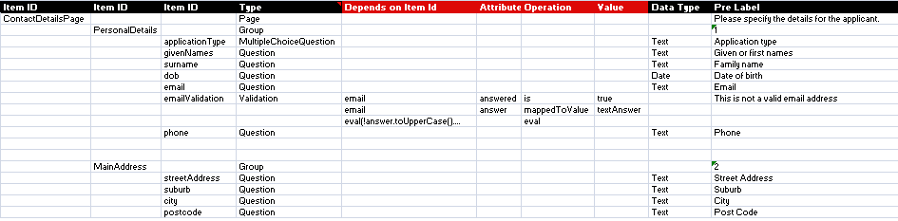
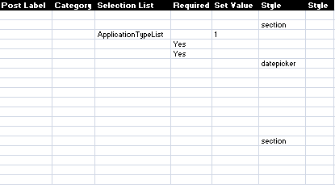
Fig 3

In fig 4 below once can see the Tohu generated section of the webpage based on the spreadsheet configured information.
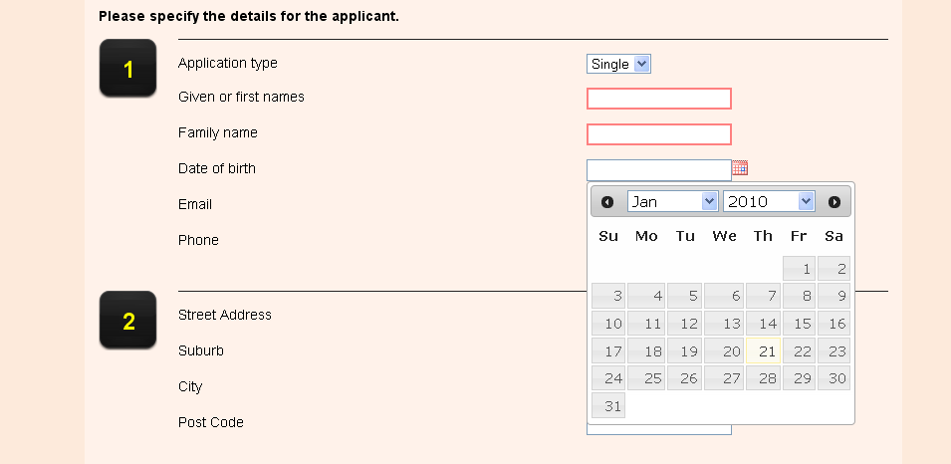
Fig 4

Tohu Answer Definitions
Lists | Reference name to the list. Used by the SelectionList column defined above
Actual Value | List item’s internal value
Displayed Value | List item’s displayable value
Depends on Item Id | List Filter, which references an existing Tohu Entities itemId
Attribute | The attribute of Tohu Entity described in the previous row
Operation | Operator to perform on the Attribute defined in the previous row
Value | Expression to match against the Attribute’s value

An example of a Collection is defined below in fig 5
Lists | Actual Value | Displayed Value | Depends on Item Id | Attribute | Operation | Value
ApplicationTypeList | 1 | Single
 | 2 | Joint

Fig 5 collection definitions
In Fig 6 below one can view the Tohu specific section of a webpage containing a collection of answers for a multiple optional Question.

Fig 6
Tohu Type Definitions
Page
Group | A logical grouping of Tohu Entity information
MultipleChoiceQuestion | A question which offers more than one answerable options of which one or more options are selectable
Question | A question with a single answer option
Note | A Tohu Entity which can provide context related information be it for a question, group, page, application.
Branch
Impact
FunctionalImpact
AlternateImpact
Validation | Explicit validation to be performed on a Tohu Question. Can reference a customised java utility function if validation is complicated
Reuse | Allows one to reuse a Tohu Entity. If it has descendents that all of its descendents must be reusable

